Forward kinematics of the UR5

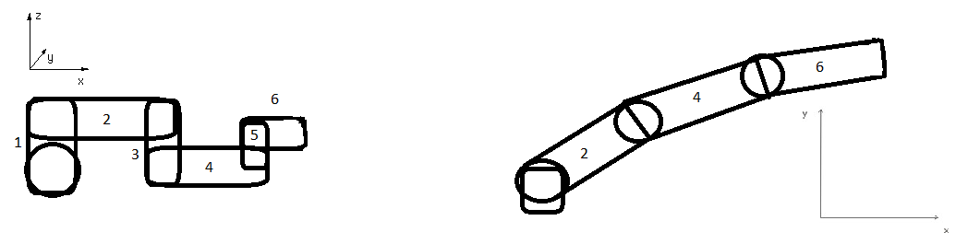

In this calculation, these diagrams representing the UR5 will be used. Circles are joints, rectangles are links. The left diagram is the UR5 as seen from above, the right diagram is the UR5 as seen from the side.

**Z-position**

To calculate the position of the arm in the x/z plane, we have to see which joints can alter this. If we look at the left diagram, we see the only link capable of doing so is the base. To calculate the position of link 6, the position of every individual link will have to be added together.

= the angle between link 1 and the x axis.

The other angles stay constant, so they are either equal to , or differ by 90 degrees.

**Z6=.**

**X-position**

To calculate the position of the arm in the x/y plane, we have to look at which joints alter it. The joints that are capable of changing the x-location of the arm are 1,2,4 and 6. To calculate the eventual position of link 6, the positions of all links will have to be added again.

1 = the angle between link 1 and the x-axis.

2 = the angle between link 2 and the x-axis.

4 = the angle between link 4 and link 2.

6 = the angle between link 6 and link 4.

The angles of link 3 and link 5 are equal to .

**X6=**

**Y-position**

To calculate the Y-position, we have to look at which joints are capable of changing it. The joints we will have to take into account are 2,3,4,5 and 6. To prevent confusion; since these links are connected perpendicularly, the angles mentioned are the ones revolving around the z-axis in the cases of link 2,4, and 6. The angles mentioned for link 3 and 5 are the ones revolving around the x-axis. To calculate the position of link 6, all positions will have to be added again.

2 = the angle between joint 2 and the x-axis.

3 = the angle between joint 2 and 3.

4 = the angle between joint 3 and 4.

5 = the angle between joint 4 and 5.

6 = the angle between joint 5 and 6.

**Y6= **